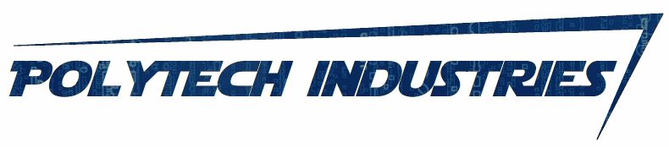

ODBC to KML
Project Plan

Version 1.0 – Dec. 1, 09
Revision History

Date | Version | Description | Author
10/01/2009 | 1.0 | Introduction(1.1-1.2) | Cody Tankersley, Kevin Duvieilh
10/01/2009 | 1.0 | Project Organization(2.0) | Cody Tankersley
10/01/2009 | 1.0 | Risk Analysis(3.0) | All Team Members
10/01/2009 | 1.0 | HW/SW Requirements(4.1-4.2) | Micah Bauer, Shane Fry
10/01/2009 | 1.0 | WBS(5.0) | Lona Smith
10/01/2009 | 1.0 | Cost Breakdown(6.0) | Lona Smith, Richard Sween
10/01/2009 | 1.0 | Project Schedule(7.1) | Micah Bauer
10/01/2009 | 1.0 | Deliverables(8.0) | Micah Bauer
10/01/2009 | 1.0 | Monitoring and Reporting(9.1-9.2) | David Giametta, Viet Nguyen
Table of Contents
1. Introduction 4
1.1. Overview 4
1.2. Abbreviations and Acronyms 4
2. Project Organization 5
3. Risk Analysis 7
4. Hardware and Software Resource Requirements 8
4.1. Hardware resources required for the project 8
4.2. Software resources required for the project 8
5. Work Breakdown Structure 9
6. Cost Breakdown 11
7. Project Schedule 13
7.1. Schedule of Events 13
8. Deliverables 15
9. Monitoring and Reporting 17
9.1. Program Monitoring 17
9.2. Quality Assurance 18

Introduction

Overview
This document is a project plan for the project ODBC to KML project that PolyTech Industries is currently designing. The ODBC to KML project was requested by USACE-ERDC-ITL. The project is a web-based application that accesses databases and analyzes the geographic information. After analyzing the information, the application will convert the coordinates into a KML format to be displayed in Google Earth. The remainder of this document will provide details on the items that PolyTech will consider while developing this project.

Abbreviations and Acronyms
AJAX – Asynchronous JavaScript and XHTML
ASP – Active Server Pages
CEO – Chief Executive Officer
HCI – Human Computer Interface
KML – Keyhole Meta Language
GUI – Graphic User Interface
QA – Quality Assurance

Project Organization

The following chart is an overview of our project organization. The name and job title of each participant in this project is listed within their corresponding box. More information on what each specific box means is listed after the chart.

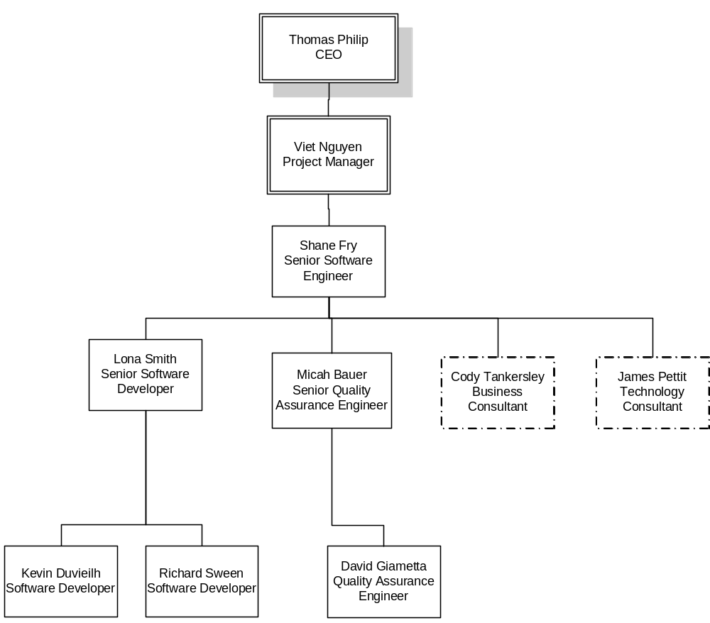

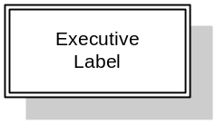 This label represents the highest executive position responsible for the project. In this project this position belongs to Thomas Philip, Ph. D. He provides guidance on the format used for the documentation and implementation phases. He also conducts reviews and inspections on the team to ensure a quality product is produced.
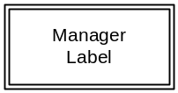 This label represents the project manager. The project manager is Sivakumar Kulasekaran. He provides more detailed guidance for the documentation and implementation. He monitors the project closely and assigns tasks to all of the team members. All changes or updates are to be reported to him by Tuesday of every week.

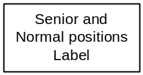This label represents several positions including:
- Senior Software Engineer – This position is responsible for managing tasks for the Senior Software Developer and Senior Quality Assurance Engineer. The position is responsible for ensuring that tasks are understood. Shane Fry is the senior software engineer of PolyTech Industries.
- Senior Software Developer – The senior software developer is responsible for managing the Software Developers’ tasks for coding the project. The senior software developer resolves conflicts with programming and will also aid in coding the project. Lona Smith is the senior software developer for PolyTech Industries.
- Software Developer – The software developer is responsible for coding the project. The software developer receives tasks from the Senior Software Developer and reports progress to the Senior Software Developer and Project Manager. PolyTech Industries employs the following software developers: Richard Sween and Kevin Duvieilh.
- Senior Quality Assurance Engineer - The senior quality assurance engineer is responsible for ensuring the quality of the project. The senior quality assurance engineer is responsible for delegating tasks to the quality assurance engineers to complete quality assurance tasks such as testing, reviews, and inspections. The senior quality assurance engineer also completes these tasks along with the quality assurance engineer. Micah Bauer is the senior quality assurance engineer for PolyTech Industries.
- Quality Assurance Engineer – The quality assurance engineer is responsible for completing quality assurance tasks in the project. This includes conducting tests, reviews, and inspections for the project. The quality assurance engineer receives tasks from the senior quality assurance engineer and reports progress on these tasks to the Senior Quality Assurance Engineer and Project Manager. The quality assurance engineer of PolyTech Industries is David Giametta.

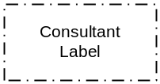 The consultant label is used for the following positions:
- Business Consultant – This position is responsible for communicating to the customer and any financial questions related to the project including budgets, wages, and equipment. Cody Tankersley is the business consultant for PolyTech Industries.
- Technology Consultant – This position is responsible for aiding the PolyTech Industries group to understand any technologies or programming languages. They aid in the technical aspects of the project. Viet Nguyen is the technology consultant for PolyTech Industries.

Risk Analysis
The following list is a list of all the risks that PolyTech Industries may face while developing the ODBC to KML project.

1. Requirements Risks
-Changing requirements
- Risk is: If the requirements change after the design phase, the project may need to be redesigned.
- How to avoid: Constant user interaction during the requirements phase to ensure that the requirements we gather are what the user desires.
- Data sets
- Nature
- Risk: We cannot anticipate all the different formats in which the data may be stored.
- How to avoid: Develop a robust system that can handle various types of inputs.
- Size
- Risk: We do not know how large the datasets will be or how much stress the size of the datasets will place on the system.
- How to avoid: Develop a robust system that can handle various sizes of inputs.
- Missing
- Risk: Without a sample dataset, we will be unable to design the system properly.
- How to avoid: Ensure that the customer delivers a dataset before the design phase begins.
2. Technology Risks
- Java trained, using .Net
- Risk: Initial development may be prolonged while developers become familiar with the .NET framework.
- How to avoid: We will begin researching the languages in advance of the development phase.
- Complex GUI
- Risk: The more user friendly the GUI is, the longer it will take to design and implement correctly.
- How to avoid: Thorough and early design within the HCI.
- Google code crashing
- Risk1: Losing all data.
- Risk2: Having the data unavailable for extended amounts of time.
- How to avoid: Make external backups and local copies of all data hosted on Google code.
- Hardware failure
- Risk: Loss in productivity.
- How to avoid: Having backup systems available for continued work on the project.
- Missing hardware/software
- Risk: Without a timely delivery of the hardware and software necessary for development, the project will be delayed.
- How to avoid: Increased communication with the customer as the deadline approaches.
- Unknown software compatibility
- Risk: Because we do not know the versions, we do not know how the software products will interact with each other.
- How to avoid: Obtaining a list of software versions and researching any incompatibilities between those software versions.
3. Team Risks
- Adding Personnel:
- Risk: Losing development time to train additional personnel.
- How to avoid: Create detailed documentation.
- Losing Personnel:
- Risk: Loss of development time.
- How to avoid: Increase the number of hours spent by each member on the project.
- Scheduling conflicts
- Risk: Delays in all aspects of the project due to individual(s) schedules.
- How to avoid: Schedule all important meetings during class times.

Hardware and Software Resource Requirements

Hardware resources required for the project
The hardware equipment used for the development of this project includes eight personal computers. Virtual machines of Windows Server 2003 will be used to simulate the web server environment. Those virtual machines will be run on each developer’s personal computers.

Software resources required for the project
The programmers in the PolyTech Industries team will use various operating systems to suit their needs, including Windows XP, Windows Vista, Windows 7. Software will be required during the project for design and implementation. During the design phase of development, the team will use various Microsoft Office applications. While implementing the project, the team will use Microsoft Visual Studio 2008 to develop the C# and ASP.NET code and Google's development services for version control, bug tracking, and wikis. The team will also use other Google services including email, calendar, and group services throughout the development process.

Work Breakdown Structure
- Project Management (50 hours)
  - Administration (10 hours)
  - Planning (10 hours)
  - Domain Research (15 hours)
    - KML
    - Google Development Tools
    - ASP.NET
    - C#
    - Ajax
    - Microsoft IIS Server
  - Risk Management (5 hours)
  - Quality Management (5 hours)
  - Cost Management (5 hours)
- Systems Engineering (30 hours)
2.1 Technical Supervision (10 hours)
2.2 System Requirements Analysis (10 hours)
2.3 High-level System Design (10 hours)
- Software Engineering (183 hours)
3.1 Software Design (103 hours)
3.1.1 Project Plan (20 hours)
3.1.2 Human Computer Interface (10 hours)
3.1.3 Concept of Operations (15 hours)
3.1.4 Software Requirements Specification (15 hours)
3.1.5 Acceptance Test Plan (10 hours)
3.1.6 Software Architecture Description (10 hours)
3.1.7 Interim Report (10 hours)
3.1.8 Acceptance Test Report (10 hours)
3.1.9 Final Report (3 hours)
3.2 Software Development (80 hours)
3.2.1 Software Coding (55 hours)
3.2.1.1 User Interface (10 hours)
3.2.1.2 Backend Functionality (45 hours)
3.2.2 Unit Testing & Debugging (25 hours)
- Support Services (26 hours)
4.1 Quality Assurance (20 hours)
4.2 Technical Training (6 hours)

Task Descriptions
Project Management Tasks
- Administration: Administration inludes assigning work to team members, supervising development, managing time sheets, and reporting development progress.
- Planning: The initial project planning includes defining team member roles and deciding what steps need to be taken to begin work on the project after reviewing the request for proposal.
- Domain Research: Before developing any part of this system, PolyTech Industries must become familiar with the system domain. Domain research includes researching KML for a better understanding of Google Earth code, Google Development Tools, ASP.NET and C# (the language the system is to be written in), Ajax, and Microsoft IIS Server.
- Risk Management: Analyzing any risks that may be associated with this project is included in risk management. Although USACE-ERDC-ITL will be managing security for the system, other risks need to be analyzed before beginning development.
- Quality Management: Quality management includes making decisions on how to devlop the highest possible quality software that PolyTech Industries can with the given resources and in the decided amount of time.
- Cost Management: Calculating the costs to develop this product are included in cost management. Costs for different phases vary based on the number of hours and the position of the team members working on each phase.

Systems Engineering
- Technical Supervision: Similar to administration, technical supervision includes supervising development. However, it is done primarily by the project manager so that he can provide input on how the system should be developed.
- System Requirements Analysis: Requirements analysis includes meetings with the customer and project manager to analyze what requirements are needed for the system. These requirements include both the high priority requirements necessary for the system to function and the lower priority requirements that are not necessary but desired if the development schedule allows for it.
- High-Level System Design: PolyTech Industries must design a high-level view of the system to better understand how it functions and to help convey ideas to USACE-ERDC-ITL. This high-level design will help serve as a foundation for the Software Architecture Description’s more detailed designs.

Software Engineering
- Software Design: The majority of the time spent developing this system will be in software design. This includes developing all parts of the system before actually implementing it. It has been broken down in this work breakdown structure based on the documents that come out of it. For a description of each document and what is included, see Deliverables (Section 7).
- Software Development: Software development includes actually writing the code for the system to develop and user interface and backend functionality. It also includes testing and debugging the software as it is being developed.

Support Services
- Quality Assurance: Quality assurance includes testing the software developed to make sure that it satisfies USACE-ERDC-ITL’s requirements and provides all functionality desired.
- Technical Training: Training includes showing the USACE-ERDC-ITL users how to use the system. A technical support document will also be developed for user reference.

Cost Breakdown
ORGANIZATION |  |  |  |  |  | Period Commence: |  | 9/29/2009
 |  | PolyTech Industries |  |  |  | Period Terminate: |  | 4/16/2010
PRINCIPAL INVESTIGATOR/PROJECT DIRECTOR
 |  | Sivakumar Kulasekaran
A. SENIOR PERSONNEL: PI/PD, Co-PI´S, Faculty and Other Senior Associates
 | (List each separately with title, A.7. show number in brackets) |  |  |  |  |  |  | Request
 |  |  |  |  |  | FTE
1. |  | Sivakumar Kulasekaran, Project Manager |  |  |  | 0.25 |  | 14,925
2. |  | Shane Fry, Senior Software Engineer |  |  |  | 0.25 |  | 9,472
3. |  | Micah Bauer, Senior QA/Test Engineer |  |  |  | 0.25 |  | 9,362
4. |  | Lona Smith, Senior Software Developer |  |  |  | 0.25 |  | 9,419
5.
6. ( | 0 | ) OTHERS (LIST INDIVIDUALLY ON BUDGET EXPLANATION PAGE)
7. ( |  | ) TOTAL SENIOR PERSONNEL (1-6) |  |  |  | 1.00 |  | 43,178
B. OTHER PERSONNEL (SHOW NUMBERS IN BRACKETS)
1. ( | 0 | ) POST DOCTORAL ASSOCIATES |  |  |  | 0.00 |  | 0
2. ( | 5 | ) OTHER PROFESSIONALS (TECHNICIAN, PROGRAMMER, ETC.) |  |  |  | 1.25 |  | 39,541
3. ( | 0 | ) GRADUATE STUDENTS |  |  |  | 0.00 |  | 0
4. ( | 0 | ) UNDERGRADUATE STUDENTS |  |  |  | 0.00 |  | 0
5. ( | 0 | ) SECRETARIAL - CLERICAL (IF CHARGED DIRECTLY) |  |  |  | 0.00 |  | 0
6. ( | 0 | ) OTHER |  |  |  | 0.00 |  | 0
 | TOTAL SALARIES AND WAGES (A+B) |  |  |  |  |  |  | 82,719
C. FRINGE BENEFITS |  |  |  |  |  |  |  | 27,148
 | TOTAL SALARIES, WAGES AND FRINGE BENEFITS (A+B+C) |  |  |  |  |  |  | 109,867
D. PERMANENT EQUIPMENT
 | TOTAL EQUIPMENT |  |  |  |  |  |  | 0
E. TRAVEL |  |  | 1. DOMESTIC |  |  |  |  | 3,000
 |  |  | 2. FOREIGN |  |  |  |  | 0
F. OTHER DIRECT COSTS
 | 1. MATERIALS AND SUPPLIES |  |  |  |  |  |  | 500
 | 2. PUBLICATION COSTS/DOCUMENTATION/DISSEMINATION |  |  |  |  |  |  | 500
 | 3. CONSULTANT SERVICES |  |  |  |  |  |  | 0
 | 5. SUBAWARDS |  |  |  |  |  |  | 0
 | 6. OTHER |  |  |  |  |  |  | 0
 |  | TOTAL OTHER DIRECT COSTS |  |  |  |  |  | 1,000
G. TOTAL DIRECT COSTS (A THROUGH H) |  |  |  |  |  |  |  | 113,867
H. FACILITIES AND ADMINISTRATIVE COSTS (SPECIFY RATE AND BASE)
 |  | Base:82,719, Rate 43%
TOTAL FACILITIES AND ADMINISTRATIVE COSTST |  |  |  |  |  |  |  | 35,569
I. TOTAL COSTS (G+H) |  |  |  |  |  |  |  | 149,437
J. DISCOUNT (100%) |  |  |  |  |  |  |  | (149,437)
K. FINAL COST (I-J) |  |  |  |  |  |  |  | 0

Project Schedule

7.1. Schedule of Events
Anticipated Contract Start 9/22/09
Concept of Operations Due 10/6/09
Requirements Analysis
    - Requirements Analysis Complete 10/22/09
    - System Requirements Review 10/27/09
High Level Design
    - High Level Design Complete 11/12/09
    - System Design Review 11/17/09
Detailed Specifications
    - Detailed Specifications Complete 12/1/09
Coding
    - Implementation Code Completed 2/16/10
Unit Testing
    - Unit Testing Completed 3/2/10
Integration Testing
    - Integration Testing Completed 3/23/10
Operational Testing
    - System Test Plan Due 11/3/09
    - Operational Testing Completed 4/1/10
Demonstration 4/6/10
Final Report Due 4/20/10

Gantt Chart
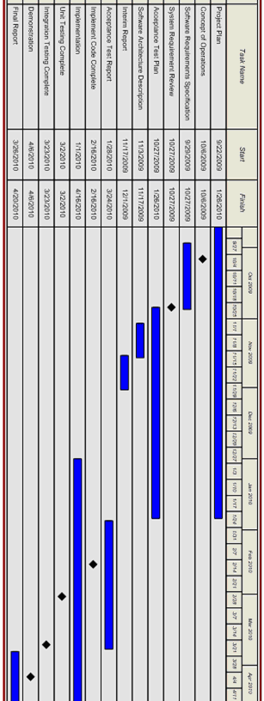

Deliverables
Project Plan
Proposed Start Date: 9/12/09
Initial Draft Due: 9/29/09
Proposed Finish Date: 1/24/10

The initial project plan will cover the Fall 2009 semester in detail and the Spring 2010 semester at a higher level. It will include details about the following:
- Guiding principles and assumptions
- Project team organization, roles, and assignments
- Tasks/subtasks, dependencies among them, amount of effort, and planned start and completion dates
- Table of off-the-shelf components, costs, if any, and associated deliveries
- GANTT chart of the project schedule to include task dependencies, milestone/deliverable dates, and personnel resource allocations for each task.

The revised project plan will cover the Spring 2010 semester in detail and review the Fall 2009 accomplishments at a higher level.

Concept of Operations
Proposed Start Date: 9/29/09
Proposed Finish Date: 10/6/09

The Concept of Operations describes the context for the system, history of user need, how it will be used, and problems the system is expected to solve.

Software Requirements Specification
Proposed Start Date: 9/29/09
Proposed Finish Date: 10/27/09

The Software Requirements Specification will specify all functional and non-functional requirements based on requirements elicitation activities. It will include details about security analysis and requirements, especially integrity of data. The Software Requirements Specification will be continuously updated as the project progresses to accurately reflect the as- built system.

Acceptance Test Plan
Proposed Start Date: 10/27/09
Initial Draft Due: 11/3/09
Proposed Finish Date: 1/24/10

The Acceptance Test Plan describes system testing, test cases, and the test plan. It is used in devising a method of testing the quality assurance of the system.

The initial draft will be based on the current version of the Software Requirements Specification.

The final version will be the basis for acceptance of the final system. It will be based on the as- built version of the Software Requirements Specification.

Software Architecture Description
Proposed Start Date: 11/3/09
Proposed Finish Date: 11/17/09

The System Architectural Description details an architectural representation of the system. It will include various architectural models.

The Software Architecture Description will specify the software architecture from several viewpoints, including navigation, database, logical, process, and deployment viewpoints.

Interim Report
Proposed Start Date: 11/17/09
Proposed Finish Date: 11/29/09

The interim report will include the following:
- A short report describing the current documentation and the current status of the project.
- Current version of the Software Requirements Specification
- Current version of the Software Architecture Description
- Current version of the Acceptance Test Plan

A signed intellectual property Assignment form from each team member will accompany the delivery.

Acceptance Test Report
Proposed Start Date: 1/31/10
Proposed Finish Date: 3/26/10

The Acceptance Test Report will document the results of the Acceptance Test Plan on a test by test basis.

Implementation
Proposed Start Date: 02/02/10
Version 1 of Complete System Due: 4/2/10
Proposed Finish Date: 4/16/10

The source code, scripts, and instructions will be delivered on a single CD.

Final Report
Proposed Start Date: 3/26/10
Proposed Finish Date: 4/16/10

The final report will include the following:
- A short report describing the final system, and each document
- As-built version of Software Requirements Specification
- As-built version of Software Architecture Description
- As-conducted version of Acceptance Test Plan
- All training materials
- A signed intellectual property Assignment form from each team member will accompany the delivery.

Status Presentations

The group will present the project's status monthly to the client representative at an agreed place and time.

Progress Reports
The group will submit a weekly report to the project manager detailing the focus and duration of their efforts during the previous week. The group will also present the project's status monthly to the client representative at an agreed place and time during the monthly status presentations. The subjects of the monthly status reports will be as follows:
10/6/09 – Software Requirements
11/3/09 – Software Requirements, Acceptance Test Plan, and Software Architecture
1/12/10 – Software Architecture, Acceptance Test Plan, Project Plan, and Detailed Design
2/2/10 – Detailed Design and Implementation
3/2/10 – Implementation
4/6/10 – Demonstration and Training

Monitoring and Reporting

Program Monitoring

The milestones and deliverables act as a way to control the progress of the project. The following procedures are being used to ensure that the project stays on schedule and team remains focused on assigned tasks to meet the milestones:

9.1.1 Management Meetings

PolyTech Industries has two meetings a week, Tuesdays and Thursdays at 12:30 P.M for progress updates, new task assignments, and reporting of the current week’s work. The meetings are coordinated and lead by the Project Manager, Sivakumar. The CEO of PolyTech Industries also attends the meetings regularly and consults with the group on their progress. These meetings help the group to ensure the project team members are on track and have tasks to accomplish towards the project.

9.1.2 Activity Reporting

PolyTech Industries employees are required to submit weekly timesheets to the Project Manager. Information on what was accomplished, any problems, and future tasks are also reported in the weekly timesheets. This lets the Project Manager know of what each member of the team is doing, has accomplished, and the amount of hours the members are putting into their tasks. These tasks are tasks that derive from the Work Breakdown Structure in the Project Plan.

9.1.3 Pair Working

The team will work in pairs on assigned tasks whenever the tasks the members are working on are related. Pair working will help the team to accomplish tasks which depend on one another or if the modules that the members are working on have related parts. Pair programming helps team members to debug one another’s code which saves time.

9.1.4 Centralized Management Interface

PolyTech Industries is using a Google Groups email address to send out emails to one another whenever needed. This is used to communicate the progress of the project and updates throughout the week outside of the weekly meetings. The email address used for the Google Group is polytechindustries@googlegroups.com. Google Docs is being used to manage all of the documents for the project and Google Code will be used for version control of the source code.

Quality Assurance

PolyTech Industries has two Quality Assurance Engineers: David Giametta and Micah Bauer who will both ensure that all deliverables are at an acceptable standard. The methods they will use are as follows:

9.2. 1 Document Reviews

All documents for this project will be read and reviewed by both David and Micah and will be given a final review by the group. These reviews will include using techniques such as Scenario-Based Reading. Each document will then be given to our CEO Dr. Phillip who conduct his own review and decide if our document is satisfactory.

9.2.2 System Testing

Constant testing throughout the development of our product will be conducted by our Quality Assurance Engineers. After our system is completed we will perform module tests on each part of the system. Next, integration tests will be performed in order to determine if each module communicates as it should. Finally, an acceptance test will be conducted to demonstrate and document the proper behavior of the entire system. Tests will be repeated iteratively until the system passes the quality assurance levels defined in the Acceptance Test Plan.

9.2.3 Configuration Management

PolyTech Industries will address configuration management using Google code and Google docs. All software submissions and documents will be based on our release schedule and stored using both Google and our own personal computers in case of failures. After the first release of the software, further revisions will have to undergo extensive testing before a new version can be released.

9.2.4 Change Control Process

All documents, once submitted, will be considered official. If changes are necessary, the team will be notify and send a proposed version with the changes to the customer. The customer will have the option of accepting, denying, or modifying the proposed version. Once both parties agree to a proposed version, the document will be updated and released. Each subsequent release of a document will be identified with a version number.

